EFY – Edges-First Y Method

Single-algorithm method for the 3x3x3 Cube

# Moves notation

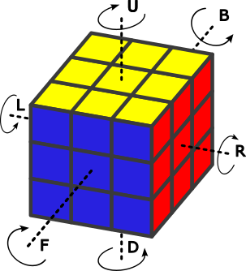

**F** **Front** 90° turn clockwise **F’** **Front** 90° turn anticlockwise

**R** **Right** 90° turn clockwise **R’** **Right** 90° turn anticlockwise

**U** **Up** 90° turn clockwise **U’** **Up** 90° turn anticlockwise

**L** **Left** 90° turn clockwise **L’** **Left** 90° turn anticlockwise

**D** **Down** 90° turn clockwise **D’** **Down** 90° turn anticlockwise

**B** **Back** 90° turn clockwise **B’** **Back** 90° turn anticlockwise

# Y-Sequence Right / Up – RU’R‘U

This sequence applied to various faces is the only thing to remember.

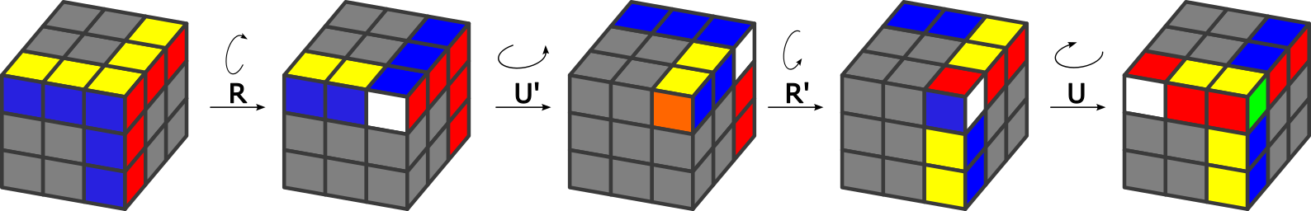

|  |  |  |
| --- | --- | --- |
| **Cycle of the 3 Edges** |  | **Swaps of Corners on faces intersection and diagonal** |
|  |  |  |
| Edges moved with face ➊ do not flip Third edge moved with face ➋ flips  Edges kept in-place after 3 Y-sequences |  | Corners on intersection ➊/➋ swap Corners on remaining diagonal swap  Corners kept in-place after 6 Y-Sequences |

# Step 1 – White cross

This step should be solved intuitively using simple moves. There are too many cases to give a complete method. Try to follow this principle:

* Identify an Edge piece with a white color, then move it to the yellow center
* Turn the yellow face to make the second color adjacent to its center
* Half-turn the face of the second color to bring the Edge to the white face

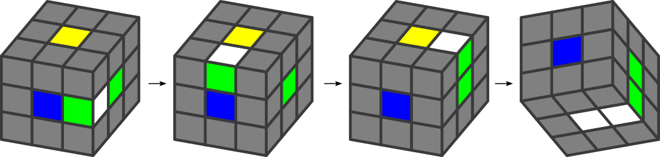

Always bring back any white cross piece, if moved during placement of other pieces.

# Step 2 – Middle edges

Here again use the yellow face as a temporary place for Edge pieces, always bring back any white cross piece if moved during placement and solve intuitively.

The principle is to bring the chosen Edge to the top layer (e.g. using a Y-Sequence to avoid touching the white cross), then turn the top layer such that the Edge color facing up is on the same face as its center (here red), then turn the face of the second color of the Edge, move the Edge to its center, then bring back white down.

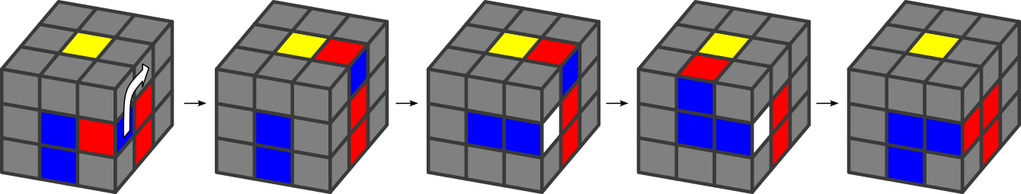

# Step 3 – Start the Yellow cross

First turn the top Yellow layer to get the most convenient position of the Edges already oriented with yellow up. You may have any number of such Edges or not at all, just find a not-so-bad position. The other Edges must be anyway moved to their correct position/orientation using the Y-Sequence.

One of the middle edges needs to be broken during the process. Select the middle Edge to break that is opposite to the Edges already at a good position.

Example to move the Yellow-green Edge to the back, breaking the Blue-Red Edge:

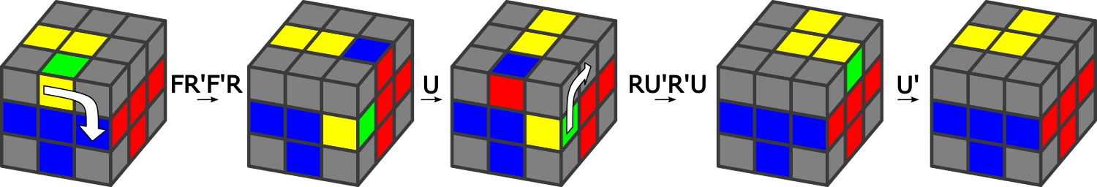

Use the Y-Sequence wisely to bring most of the Edges of the top layer in their position. If you’re lucky (probability ½), you can finish the yellow cross. If not, there is a parity problem, see the next step.

# Step 4 – Finish the Yellow cross after parity quarter-turn

While trying to move the Edges on the top layer, at the end typically 3 last Edges need to be placed around a Corner: 2 on top plus the middle Edge that was broken.

Now 2 alternatives: either the **3 last Edges are ordered such that rotations/flips around the Corner put them in the right position**, or not. For example:

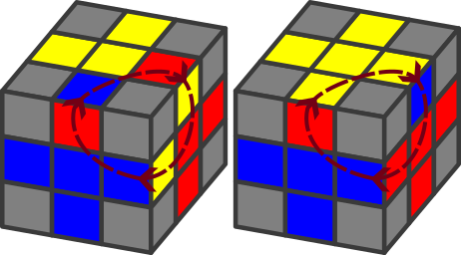 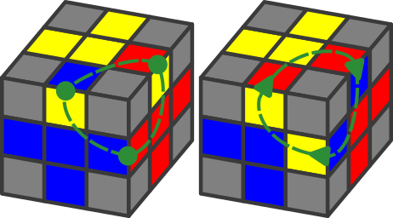

BAD: 3 last Edges not placed after rotations GOOD: a few Y-Sequences will solve

🡪 In the BAD situation, i.e. if the last 3 Edges cannot be solved by Y-Sequences only, then the 4 Edges of the top layer need to be moved by a “quarter-turn”.

This “quarter turn” is done by alternating 4 Up/Right Y-Sequences with 3 Up-moves:

* Up/Right Y-Sequences moves each Edge by 90° around the yellow center
* Up-moves place the next Edge for the next Y-Sequence.

Actually it is a simple and straight-forward algorithm, even if repetitive.

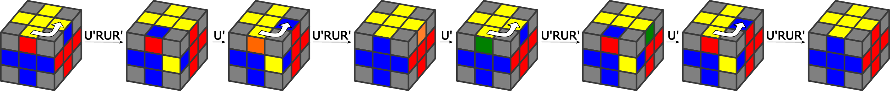

# Step 5 – Place and orient the corners

At this point, all Edges should be good. Corners can be moved around, without changing the Edges, using always the same technique:

* Series of Right/Down Y-Sequences swap diagonal Corners on the Front face
* The top layer is turned as necessary to select the Corner to be swapped
* Series of 3 or 6 Y-Sequences must be completed to avoid breaking the rest

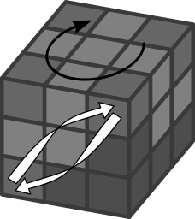

Use the Yellow or the White face as top layer (but any face can work). Do not forget to always complete the series of 6 or 3 Y-Sequences, even if a corner would be misplaced at the end. The technique needs to be applied several times at different positions to complete the cube.

A pleasant finger trick with ring fingers can be played for the Right/Down Y-Sequence